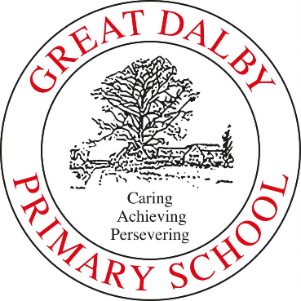

Great Dalby Primary School
Great Dalby School Results 2021-22
Great Dalby Primary School
Please find below, our assessment results for the End of Year 2021- Academic Year 2021-22
Early Years Foundation Stage
Achieving Good Level of Development | 61%
Phonics Screening Checks
Year 1 | 95% National 75%
Year 2 (Re-sits) | N/A
Key Stage 1 (End of Year 2)
 | Reaching Expected Standard | Above Expected Standard
Reading | 83% National 67% | 39% National 18%
Writing | 67% National 58% | 6% National 8%
Mathematics | 78% National 68% | 22% National 15%
Key Stage 2 (End of Year 6)
 | Reaching Expected Standard | Above Expected Standard
Reading | 85% National 74% | National 28%
Writing | 75% National 69% | National 13%
Grammar, Punctuation and Spelling | 70% National 72% | National 28%
Mathematics | 80% National 71% | National 22%
Reading, Writing and Mathematics Combined | National 59% | National 7%
Key Stage 2 Progress
 | Average Progress
Reading | Awaiting
Writing | Awaiting
Mathematics | Awaiting
Scaled Score
Reading Average Scaled Score | 104.68
Grammar, Punctuation and Spelling Average Scaled Score | 104.47
Maths Average Scaled Score | 105
*Note: The figure for ‘Reaching Expected Standard’ includes those working ‘At’ and ‘Above’ Expected Standard (i.e. At Greater Depth)

